**Foster Care Trends in America**

Group Members: Hannah Duncan, Geoffrey Johnston, Melody Yu, Timothy OMalley, Kristan Pruett

Topic: What will the foster care environment look like in the future?

Description: Foster care in America is becoming more and more of a pressing issue on communities around the country. State agencies are becoming more and more saturated with children requiring foster care with not enough families to take in the children affected by separation.

Our goal is to be able to predict the future need of foster families based on data obtained from 2010-2019. The first dashboard shows the number of foster children in care by state in 2010 and 2019 and shows the difference; showing a 4.2%

upward trend over the 10-year span, and unfortunately does not take into consideration children that age out of the system.

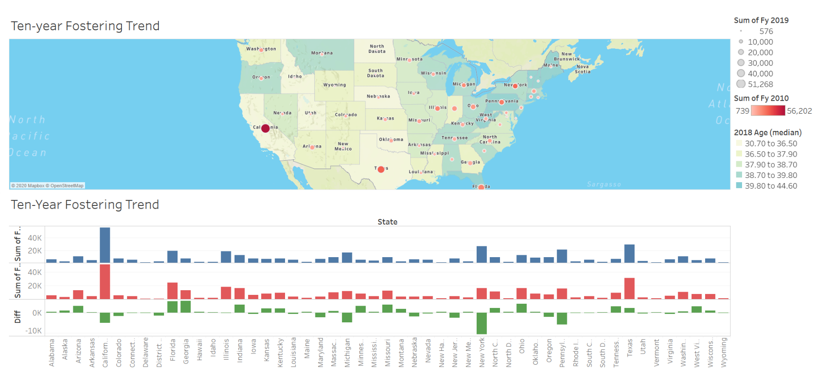

Background: We are providing an interactive website for the user to research the number of children in care, the number of adoptions and the number of Termination of Parental Rights (TPR) in the United States from 2010-2019 by selected state.

Every state is responsible for the administration of their own foster system; some states even subcontract this out to other community organizations. The data reported is by state by year.

Provided below is an example of the website page we will develop in conjunction with the regression analysis.

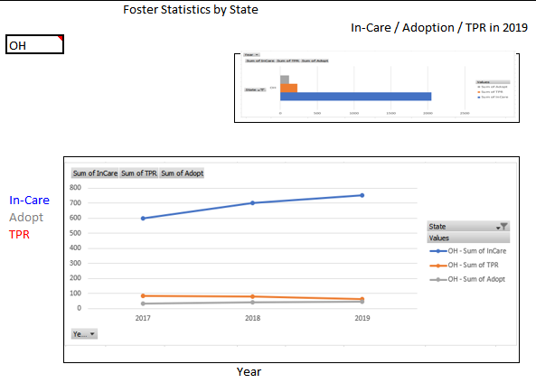

Predictions:

Using a regression analysis from Sklearn we are going to develop a model to predict what the foster care needs will be 5, 10, and 20 years from now. We will be looking at predicting the number of children in care as well as TPR predictions for the future as that can also be used to estimate group home needs for children that age out of the foster system without being adopted. We hope to be able to perform this prediction by state but may only be able to view the prediction in aggregate.

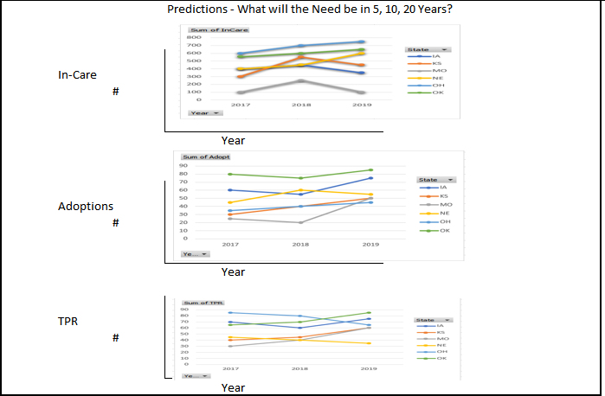

Links:

* "Foster Trends in America:

<https://www.acf.hhs.gov/cb/resource/trends-in-foster-care-and-adoption>

* GitHub Link:

https://github.com/gemelodyyu/Trends-in-Foster-Care-and-Adoption

Tech being used:

* JavaScript
* Python Pandas
* Tableau
* HTML
* Plotly
* Machine Learning